Training Day 5
INVENTORY
INDEX

1. Reconcile Current Stock 2
2. Reconcile Opening Stock 3
3. Shortage/Surplus 4
4. Issue/Receive Location Transfer 5

Reconcile Current Stock

You can use this option to reconcile the stock of your store. It will show you the current stock of computer and will ask you to enter actual physical stock so that it can update the current stock as per the actual stock. It will automatically create shortage/surplus entries as per the difference in current & actual stock.

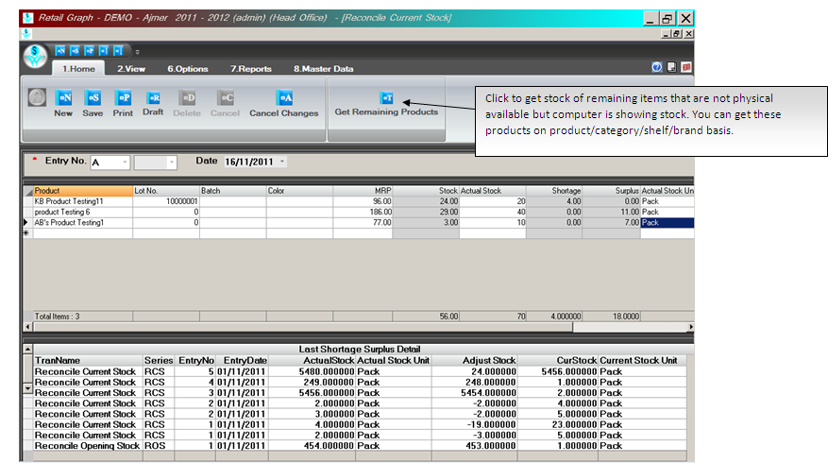

Reconcile Opening Stock

RetailGraph offers you the facility to reconcile opening stock of your store. You can use “Reconcile Opening Stock” option available in Inventory menu to reconcile your opening stock. These entries are considered in opening stock.

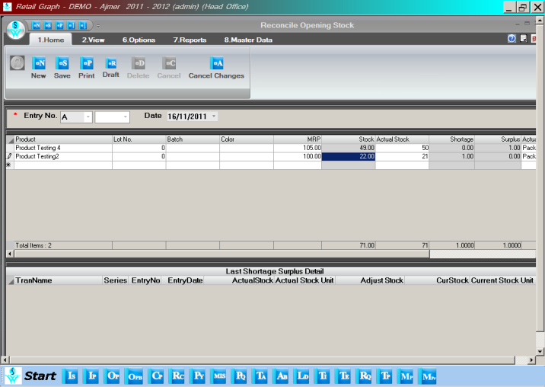

Shortage/Surplus

If some point of time you may find difference in your physical stock & the current stock being shown by computer. You can use Shortage & Surplus option from Inventory menu to correct the current stock.

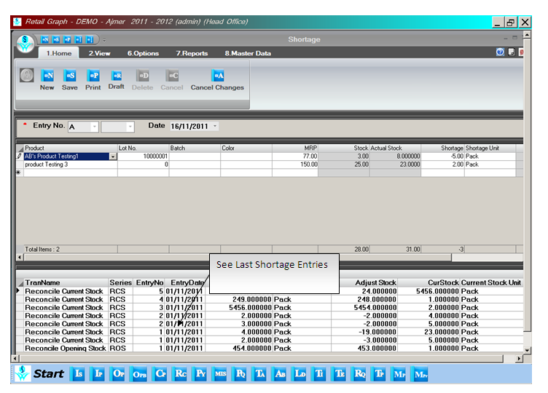

Issue/Receive Location Transfer

Issue Location Transfer: This option is useful to issue goods from one stock location to another stock location. This option is also used to issue goods from central store to branch. You can issue goods received through purchase/Challan directly from here using “Get Purchase List option”. You can also use this option to transfer expired items to non saleable stock location using “Collect Expiry Data” option. You can also issue all items from one location to another location using “Transfer All” option. This option can also be used to issue goods as per the indent received from other location.

