Training Day 4
REPORTS
INDEX

1. Ledger Accounts 2
2. Sales reports 3
3. Purchase Reports 4
4. Inventory Reports 5
5. Product Query 6
6. Customer Query 7
7. Vendor Query 8
8. Rate & Stock Query 9
9. Stock Query 10
10.MIS View 11

In previous session we learned about receipts, payments, PDC handling, managing outstanding & accounts entries. You should now start receipts & payments and manage outstanding of customers & suppliers. This training session is dedicated to accounts reports & queries, VAT forms and various MIS reports related with sales, purchase, inventory & profit analysis

RetailGraph is integrated with financial accounting upto Balance Sheet. RetailGraphprovides you the option to get branch (location) wise trial balance, profit & loss account, trading account & balance sheet so that you can evaluate the position of every branch separately.

Ledger Accounts

It displays all the entries of a ledger. User has the option to see location and account wise ledgers

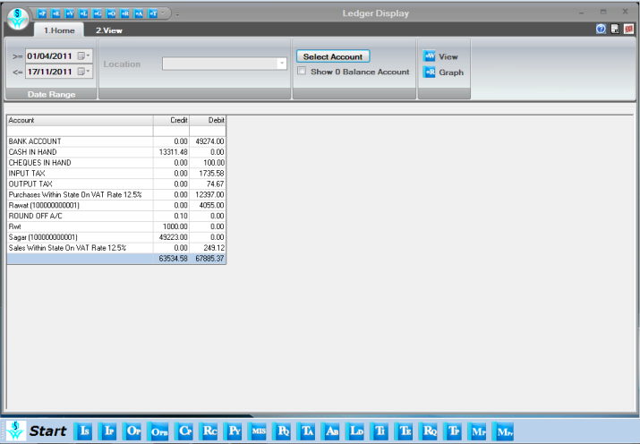

Apart from accounting reports, the user has also option of viewing different types of sales, purchase, inventory and analysis reports.

Sales reports

In the section of sales report, user has the option of viewing product wise, refer by wise and customer wise detailed sales reports.

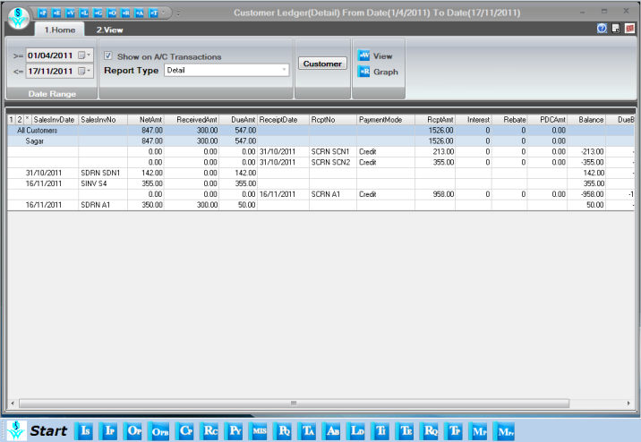

Purchase Reports

In section of purchase report, user has the option of viewing product wise, refer by wise and vendor wise detailed purchase reports.

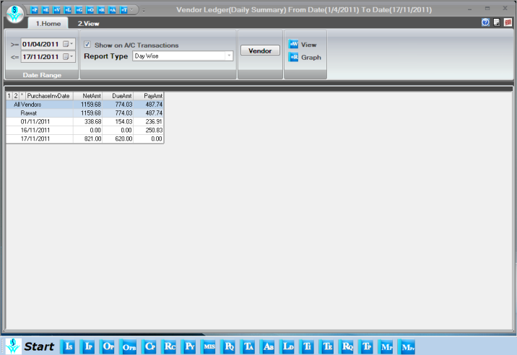

Inventory Reports

In this section, User has the option to view stock reports by different product attributes.

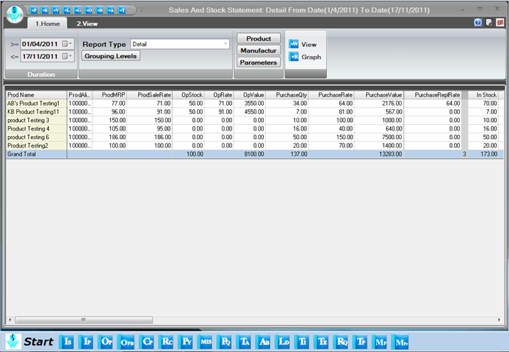

Product Query

In Product query option we can have all the details of a product on which date how much quantity of a product is in and out with lot wise and location wise details. Here we can get stock as on of a product in selected date range and current stock simultaneously. In product query report we have columns named “Issued(ALT+S)” and “Received(ALT+R)”.If we do double click on these columns then we get respective details of sales and purchase transactions. So product query is a very useful tool to have transaction history of a product.

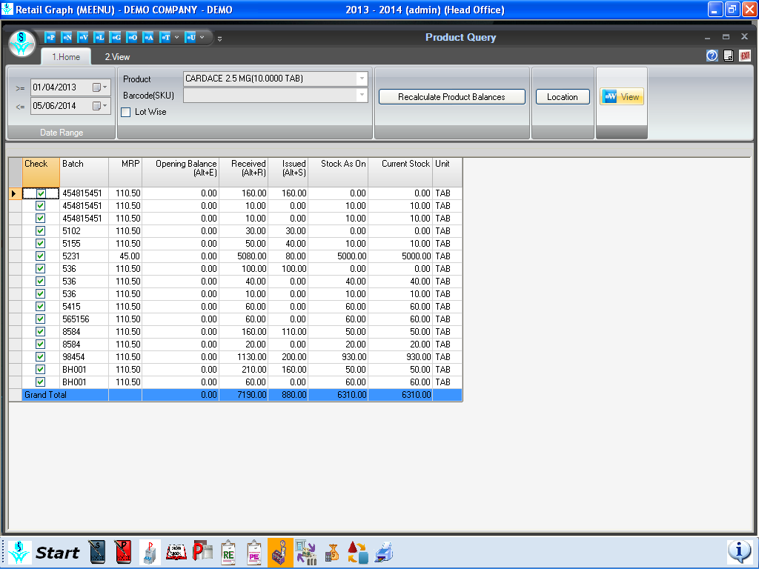

Customer Query

In Customer query tab we can get all the transactions of a customer which were made in the selected date range. In customer query we can find outstanding of the customer as well as ledger detail also. Products which were sold to customer also can be found here.

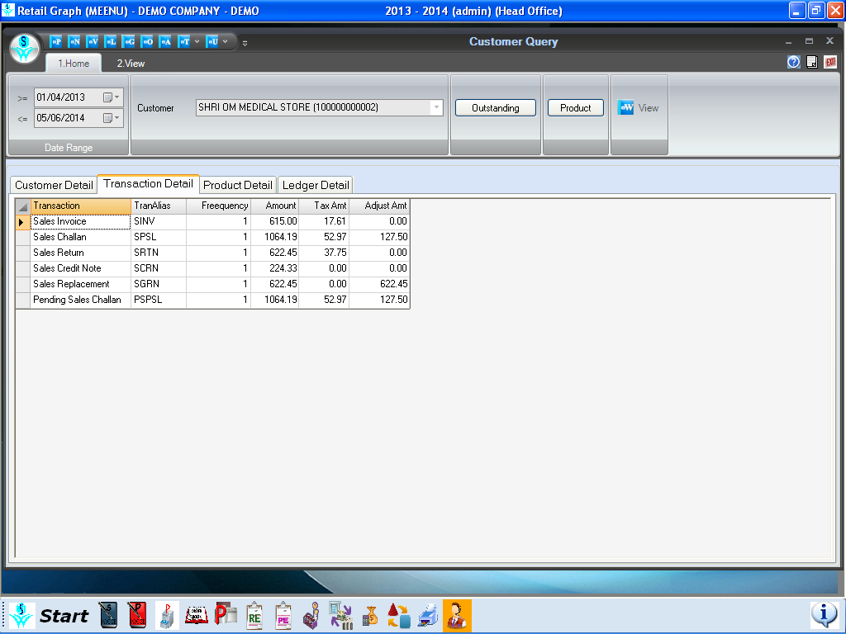

Vendor Query

In Vendor query tab we can get all the transactions of a vendor which were made in the selected date range. In vendor query we can find outstanding of the vendor as well as ledger detail also. Details of products which were purchased from the vendor also we can get from here.

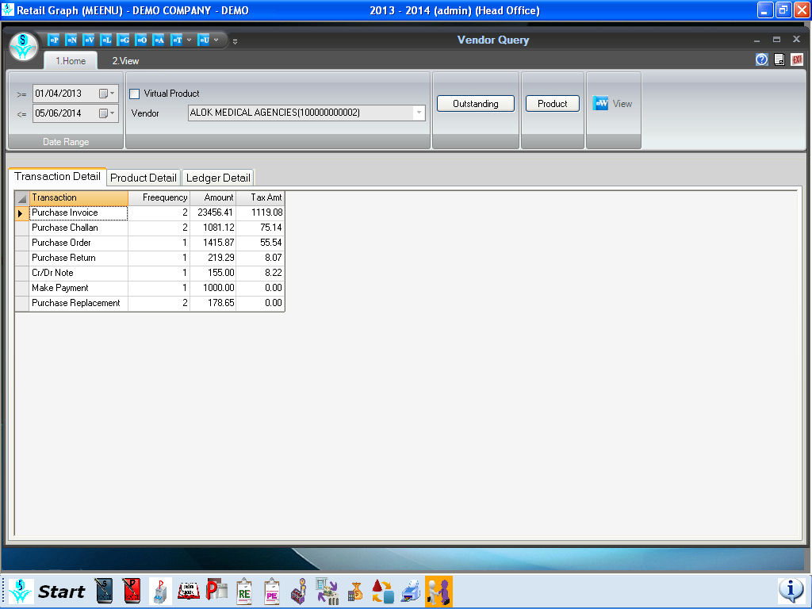

Rate & Stock Query

In Rate & Stock query option we can find a product’s rate detail, lot detail, Vendor detail and scheme detail. Here we can generate barcodes of a product from any lot no. with required no. of labels but for that lot no. must have that much required stock.

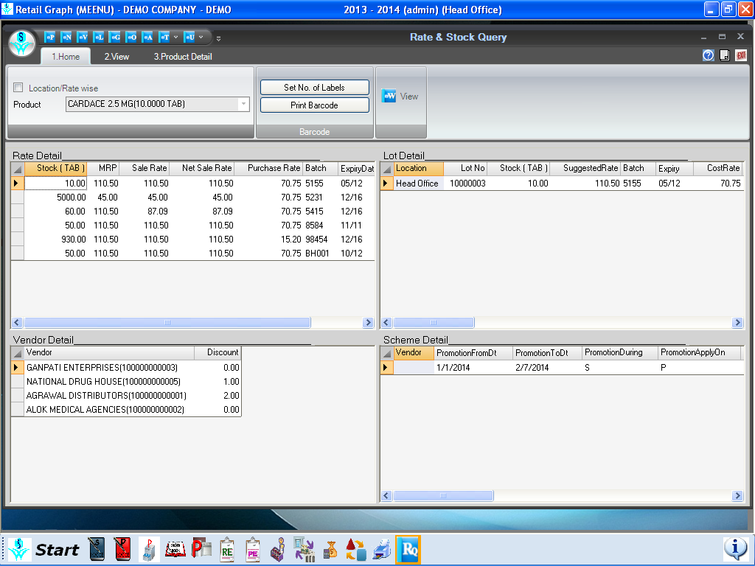

Stock Query

In stock query tab we can find a product by just putting Barcode, Lot, Manufacturer, Color, Batch, MRP in given relative field. So stock query is quite a very useful option to find a product if we know one or more thing about the product that is mentioned earlier.

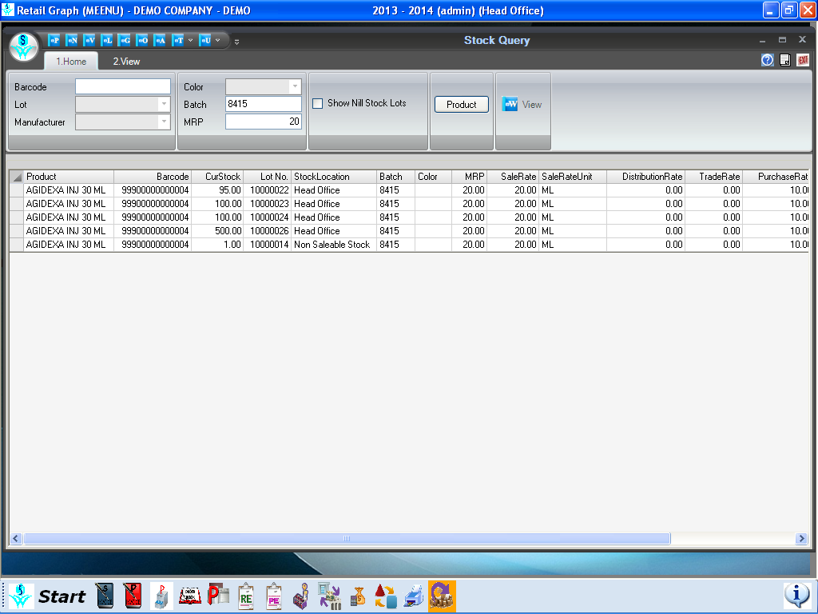

MIS View

In MIS View option we can have category wise stock value, Best selling item, Best selling products. For Inventory (items) there are analysis report which are based on marketing company wise Stock Value, Highest Stock Item qty, Item not sold, Item below Min. Level, Item above Max. level. Over here we can get vendor wise ,Category wise ,Product wise, Date wise, Tax code wise, Brand wise, Marketing co. wise purchase and purchase return transactions which have been made in a selected date range. Likewise sales and sales return analysis reports which are based on customer wise, Product wise, Sales Persons wise, Category wise, Tax code wise, Brand wise, Date wise , Marketing co. wise are generated in MIS view. There is also a payroll column in which we can get information about in service employee, registered employee and by this report we also come to know who are the top 10 sales persons.
