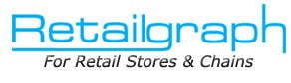
Advanced Training
INDEX

1. User Role/Rights 2
2. Reposting 4
3. Recalculating Product Balances 5
4. Log 6
5. Facilities 8

User Role/Rights

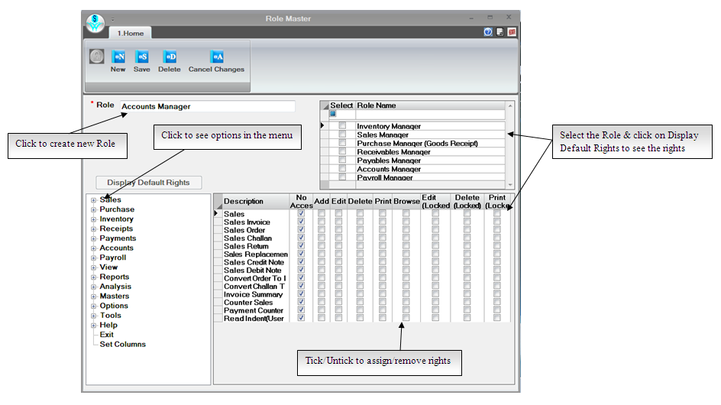
What is a Role?

The actions and activities assigned to or required or expected of a person or group is called a Role. In RetailGraph you will find some predefined roles that we have in a business like Inventory Manager, Sales Manager, Store Head etc. In RetailGraph you can create department wise Roles and can assign department wise rights to every role as per its area of operations.

How to create New Role?

To create a new role simply click on New tab as shown in the figure and enter all the required information.

How to assign rights to a Role?

In RetailGraph you can even assign particular rights (add/edit/browse/delete/print etc.) for a particular transaction in Role. To assign rights in a Role for a particular transaction please modify the Role and select the transaction type & click on “Display Default Rights” button. Associated rights for that transaction type will appear in list that you can change as per your requirement by ticking or removing the tick from the check box.

User

User simply is the person who is going to use the software. You can create different users for logging in the software. RetailGraph offers you the facility to restrict every user only to its assigned area of operations. You can assign department wise role & user wise access rights for Inventory, Purchase, Sales, Accounts, Payroll, Store head & other departments.

How to create a User?

To create a new user simply click on New tab as shown in the figure and enter all the required information.

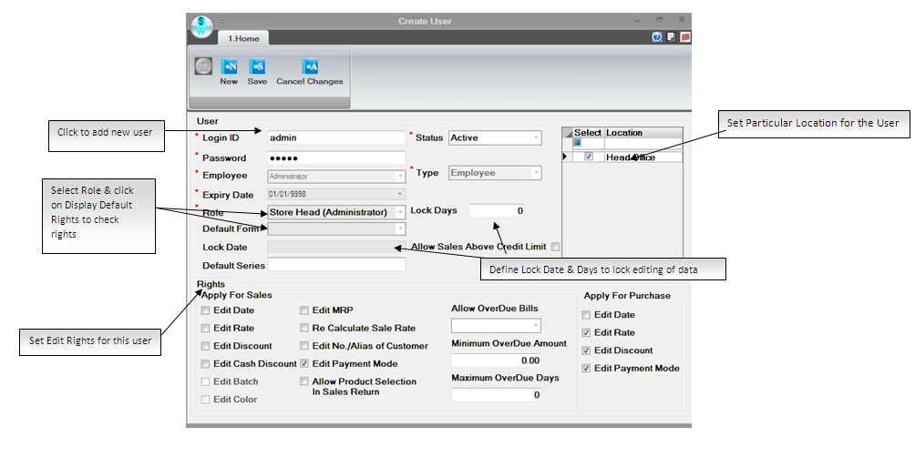

Reposting

In the last session we learned accounting and MIS part of RetailGraph. Now in this session we will know about the different options that are required for troubles shooting

In RetailGraph posting of invoices &other entries is controlled through Transaction Series Master. If due to some reason the posting of any invoice or any other entry is changed or removed from accounts, you can repost the entries using reposting options available in Options->System maintenance->Reposting menu. You can also find options to re-calculate account balances of customers, vendors & other accounts in this menu.

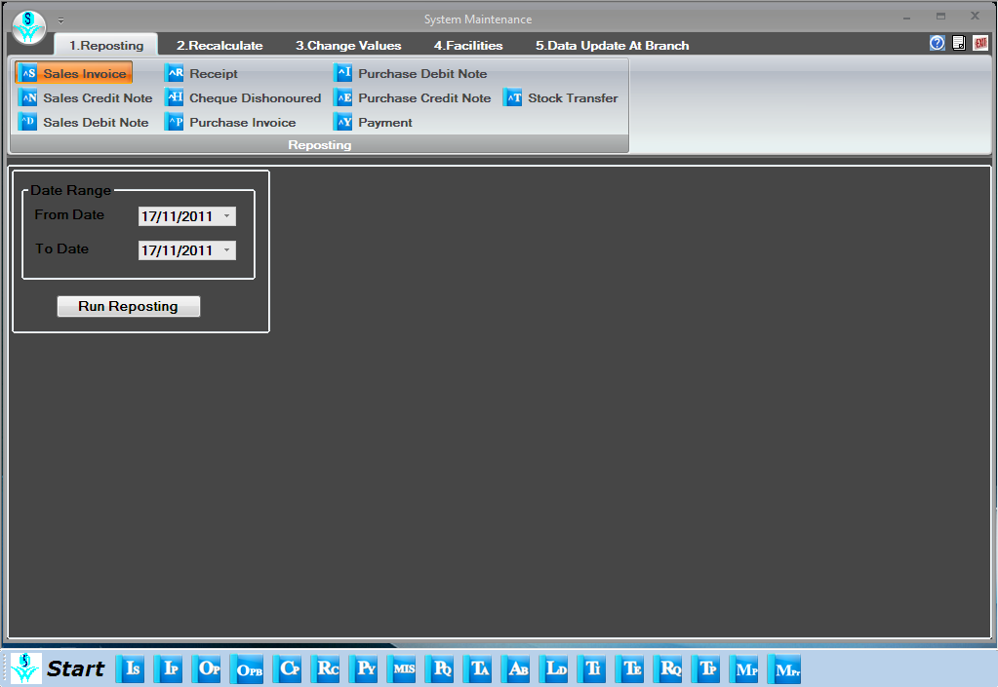

Recalculating Product Balances

Sometimes you may need to recalculate product balances especially if you have imported some entries from excel sheet then you can use Recalculate Product Balances option from Options menu. When it finds difference in items it will show the list of items in which difference is found in stock and will give you the option to “Update Stock”, Create Shortage/Surplus or Keep Stock As It is” so you can select the option as per your requirement.

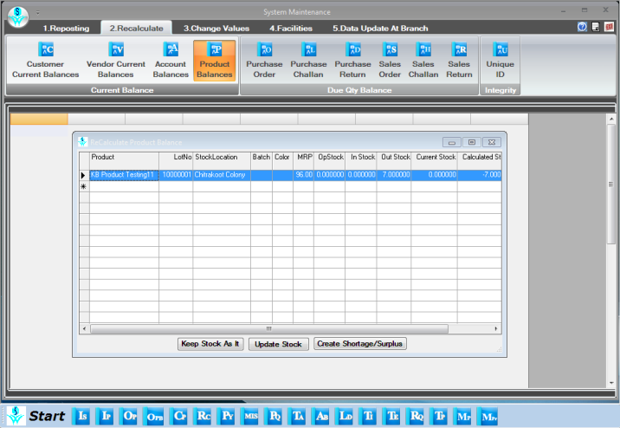

Log

RetailGraph keeps the log of all the transactions that are modified after printing. You can see the original transaction entry (before modification) using Log. You can always have an eye on the changed/modified transactions. Besides getting Log details from Options->Log menu you can also check following check list report available in Reports menu to see the summary & details of transactions done by a user.

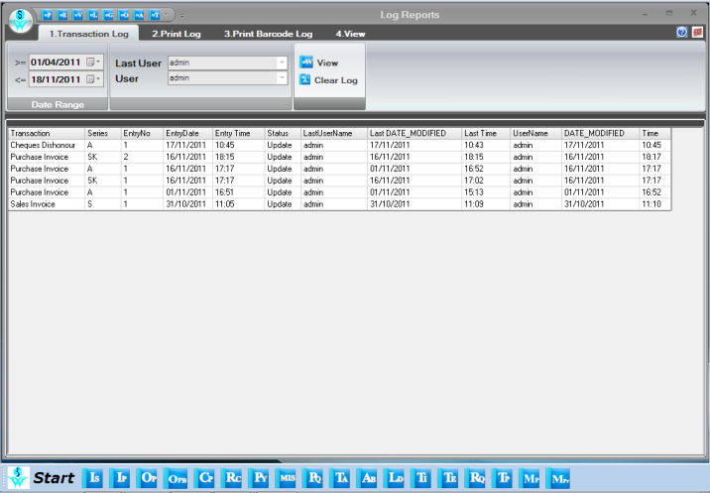

User Check List

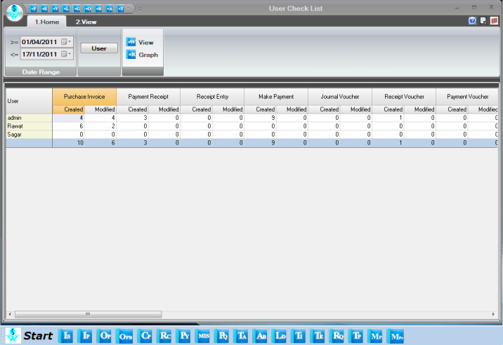

Facilities

There are many more features like Alert Message, SMS facility, Text editor, Calculator, spread sheet etc. that help you in managing your business more efficiently.

Close Financial Year (10 m)

You can close the current financial year using Close Financial Year option available in Option menu. You can close the financial year transaction series wise. Please note that it will not allow you to add any entry in the series once it is closed.

